Battery Condition Analyzer User Manual

ENS-22011-V1.3

Catalogue
1. INTRODUCTION 3
1.1 SAFETY INFORMATION 3
1.2 OPERATING PRECAUTIONS 3
2. ABOUT BT-301 4
2.1 ACCESSORIES 4
2.2 A_{PPLICATION} 4
2.3 FEATURE 5
2.4 T_{ECHNICAL} P_{ARAMETER} 5
3. OPERATION 6
3.1 MEASUREMENT PREPARATION 6
3.1.1 Main Unit Structure and Operation 6
3.1.2 Wire Connection 7
3.1.3 Power On 8
3.1.4 About Reference Values 8
3.2 M_{EASUREMENT} 9
3.2.1 Test for Single Cell 9
3.2.2 Test for Battery String 10
3.3 D_{ATA} M_{ANAGEMENT} 11
3.4 S_{YSTEM} M_{ANAGEMENT} 12
3.4.1 Instrument Calibration 13
3.4.2 Language 13
3.4.3 Time Setting 13
3.4.4 Firmware Version and Update 13
4. DATAVIEW SOFTWARE 14
4.1 SOFTWARE INSTALLATION/UNINSTALL 14
4.1.1 Software Installation 14
4.1.2 Software uninstall 15
4.2 SOFTWARE OPERATION 15
4.2.1 Import Data 15
4.2.2 View & Delete Data 16
4.3 HELP 20
4.4 HOT KEY 20
5. SERVICE AND MAINTENANCE 20
5.1 CLEANING 20
5.2 STORAGE 21
5.3 BATTERY MAINTENANCE 21
6. FAQ 21
7. APPENDIX 21

1. INTRODUCTION
This Users Manual gives full information on how to use7700IRBattery Condition Analyzer (hereinafter called “Analyzer”) safely and effectively. Please read the manual carefully so as to obtain maximal performance of the Tester.
Warning: Read this manual completely before connecting and powering on the Tester to avoid possible damage caused by improper use of this instrument.

1.1 Safety Information
For your protection, please read this safety information completely before operating the activator.
Carefully observe all warnings, precautions and instructions.
WARNING: Servicing described in this manual is to be done only by qualified personnel. To avoid electric shock, do not service the instrument unless you are qualified to do so.

DANGER | Safety testing has been done on this instrument thoroughly before shipment. However, mishandling during use could result in injury or other bad consequences, as well as damage to the instrument. Make sure that you understand the instructions and precautions in the manual before use. We disclaim any responsibility for accidents or injuries not resulted directly from instrument defects.

Safety Symbols
Description of symbols used in this manual.
DANGER | Indicates correct operation to prevent an extreme hazard that could result in serious injury or other bad consequences to users.
WARNING | Indicates correct operation to prevent a significant hazard that could result in serious injury or other bad consequences to users.
CAUTION | Indicates correct operation to prevent possible injury to users or damage to the instrument.
NOTE | Indicates advisory items related to performance or correct operation of the instrument.

1.2 Operating Precautions
Safety information
- ENS-7700IRis widely used in power utility, telecom machine room, industrial production management and the alike for testing of resistance/conductance and voltage of batteries. It may somehow be dangerous during operation. Only qualified technicians or specialized trained personnel are recommended to use it.
- This device includes a LCD touch screen. Please avoid crashing, moisture, hard scratching or any other operation that may damage the screen.
- This device includes a rechargeable Lithium battery. Please only use the manufacturer's battery charger to charge. The rechargeable batteries may get heat during charging. User should take care when taking out batteries after charging. Disconnect the charging unit from the power supply when it is not in use.
- Do not try to uninstall the device by yourself. If necessary, Please contact us for some help.

Disclaimer
We will not be liable to any accessories/product malfunction or damage, or any personal harm caused by any misuse of product, illegal purpose of using this device or any other way not described in this user manual.

2. ABOUT7700IR
ENS-7700IRis a new generation of battery tester with touch-screen. It is strictly designed to evaluate and maintain all stationary power systems including Uninterruptible Power System.
Via accurate testing of resistance (or conductance) and voltage, it gives an indication of battery capacity and technical status. The measurement data can be read on the instrument display directly. And it can also be uploaded to PC simply by using the USB drive. With the analyzing software, you could not only keep a record of the testing result but also have detailed analyzing for the status of batteries in different testing conditions.

NOTE:
This manual will mainly use resistance testing as example to explain the operation of the Analyzer. Measurement of conductance is generally the same.

2.1 Accessories
After receiving the instrument, make sure you have all the following parts.
Name | Number | Name | Number
Carrying case | 1 | Testing clamp (pair)* | 1
Main unit | 1 | Pin type probe(pair)* | 1
USB converter | 1 | USB drive | 1
User manual | 1 | Power adaptor | 1
Note: Testing clamp and pin probe are optional to users. You could select either of them or both.
Please confirm with your supplier for this option.

2.2 Application
ENS-7700IRBattery Condition Analyzer is widely used in the following areas:
- Telecom: Central Office, data processing centers and Remote Sites
- Power Utility: Switchgear, Power Station and Power Plant
- Financial Institutions: Corporate Data Centers
- Petrochemical: Process Control systems
- Offshore platforms
- Government: Local and regional
- Tax and Revenue Processing Centers
- Homeland Security, Schools, Army and Navy
- Air force Facilities, Fire and Police Agencies
- Hospital UPS system
- Electrical vehicle suppliers
- SLA battery manufactures

2.3 Feature
- One unit in two, smart switch to measure both internal resistance and conductance of batteries.  Wide test range up to 6000Ah for Lead-Acid or Nickel-Cadmium single battery which is up to 16V  Field proven accurate and repeatable measurement to identify battery health.
- Very fast and consistent measurement of battery or multiple batteries (with setting once) in seconds
- It adopts advanced measurement way of AC signal discharge to test internal resistance or conductance
- User friendly TFT touch screen and key pad as alternative operation
- Big memory for measurement data storage of more than 100,000 cells
- Universal micro USB for data exportation and also tester charge
- Functional PC battery management software for recording of full battery info and easy report print out.
- Battery pack is durable in the field with testing time of 8-12 hours

2.4 Technical Parameter
Model Numbers:
BT-301P (Base Kit with pin probe)
BT-301T (Base Kit with testing clamp) BT-301C (Complete Kit with both pin probe and testing clamp)

Applications:
Test single Lead-Acid or Nickel-Cadmium cell or battery string (one by one after setting once).
Cell types supported: 1.2V, 2V, 6V, 12V and other customized types up to 6000Ah. Voltage:
0.000V—25V DC

Resistance:
0.001 mΩ--100mΩ

Conductance:
100 - 19,990 Siemens

Test Data Storage:
100,000 cells stored internally, unlimited with
USB drive exportation

Accuracy:
Resistance/Conductance: 1%
Voltage: 0.15%

Voltmeter Resolution:
1mV

User Programmable Functions:
- Customized battery types
- Low voltage alarm setting
- High resistance alarm setting
- Test mode (push button/touch screen/auto
start)
Cable Options:
- Pin probe
- Test Clamp
- Custom cables by quotation

Power supply:
- Li-ion battery (4000mAh), 8~12hours working time after full charge

Display:
272*480 pixel, 4.3”TFT Touch Screen LCD

Data Transfer:
USB via micro USB cable

Operation Environment:
0~40℃, 90% relative humidity,
non-condensing

3. OPERATION

3.1 Measurement Preparation

3.1.1 Main Unit Structure and Operation
Below are the pictures for the main unit:
Storage Temperature:
-20~50℃

Over Voltage Protection:
- Auto-reset disconnect
- Reverse polarity protected

Housing Material:
Acid resistant ABS plastic santoprene overmold

Tester Dimensions:
L186*W98*H40 mm

Analyzer Weight:
0.45KG

Shipping Weight:
Approximately 2.8Kg

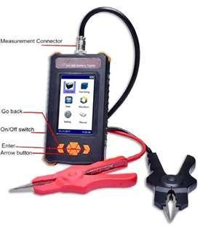
Fig 3.1.1A Operation of menu:
Operation on the menu of Analyzer could either be done via keypad or touch screen (resistive screen).
The left button is generally for going back. It is also used for switching from one line to another during cell test and string test. The up and down arrow buttons are also used to change input numbers during parameter setting.

Picture for top and bottom of main unit:
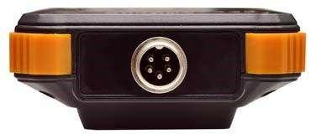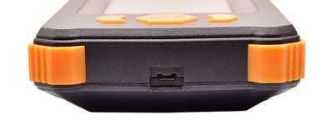

Top Bottom Fig 3.1.1B
The top panel is for connection with alligator testing clam or pin probe for measurement.
The bottom connector is for connection with USB converter for data exportation and also battery charger of main unit.

3.1.2 Wire Connection
Before measurement, please first connect the testing clamp or pin probe with main unit and fix the screw like Fig 3.1.2.1. Then connect the black clamp with negative post of battery and red with positive.
NOTE:
- To enhance the measurement accuracy, please try to connect the clamp around the Posts of battery. Rust or any insulating material (e.g. glue) around the posts will increase the resistance. Therefore, please try to avoid these causes before connecting the clamps.
- Measurement of ENS-7700IRis based on 4-point measurement. Each clamp has two metal points that are connected with the battery posts during measurement. This is same to the pin type probe. So each time when you use the pin probe for measurement, make sure that all the four pins on the pin probe should be connected with the battery posts well.
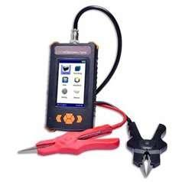
Fig 3.1.2.1 Fig 3.1.2.2

3.1.3 Power On
Switch on the power on/off button, you will see the main menu of the Analyzer with the options including measurement for single cell, measurement for battery string, data management, waveform measurement, system setting and user manual. We will introduce them one by one in the following context.
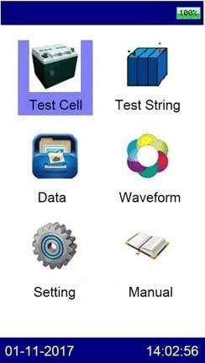

Fig 3.1.3

3.1.4 About Reference Values
ENS-7700IRhas pre-installed reference resistance for some common battery types. These values are average resistance values got from samples of strong battery strings similar in condition and age of usage. Generally, a sample of 30 new or healthy batteries are tested to obtain a value representative of a new online battery 90 days after installation. By comparison, the differences between test results and reference values will help you determine the string capacity and health status for further solutions.
Differences may reflect how a string was treated, installed, or maintained.

How to specify your reference values?
Reference values in ENS-7700IRmenu may not universally fit the batteries that you are testing. Therefore, you are suggested to specify your own reference values if any. You have the following options to set your reference value:
- Consult to your document from battery manufacturer for the reference values for the batteries that you are testing.
- Test the batteries in the string and use the lowest conductance under correct way of test for reference value. For cells ranking in the string, please refer to 3.3 Data Management.

Indications of Battery Condition
Below is the definition of the testing result for battery and battery string.
Indication | Reference | Guide
Good | 0.8≤R%<1.15 | -20%≤Measured resistance fluctuation<15%
Pass | 1.15≤R%<1.5 | 15%≤Measured resistance fluctuation <50%
Warn | 1.5≤R%<2.0 | 50%≤Measured resistance fluctuation <200%
Fail | 2.0≤R% | Measured resistance fluctuation>200%
Abnormal | Vm<0.9 OR Vm>1.2 or  R%<0.8  Battery is Abnormal | Vm<0.9 OR Vm>1.2 or  R%<0.8
NOTE: You could also see reference values in Appendix of this manual.

3.2 Measurement

3.2.1 Test for Single Cell
This is for testing single cell. To do this, you will need to set the parameter of the cell before measurement. If you have several blocks of batteries of the same rating (e.g. 2V, 100Ah), you are suggested to use “string test” (see 3.2.2) which will be much more time-saving and convenient for data management in our PC software.

Select “Test Cell” in the menu to enter the screen for parameter setting. (See Fig 3.2.1.1).
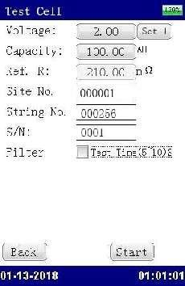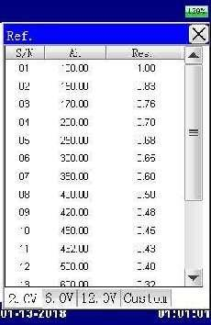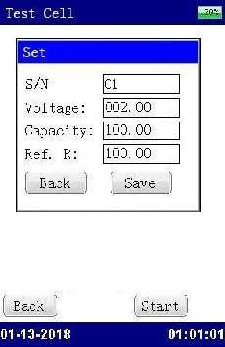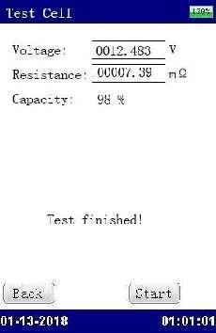

Fig 3.2.1.1 Fig 3.2.1.2 Fig 3.2.1.3 Fig 3.2.1.4

Here is explanation of each item for parameter setting as below:
Voltage: Click the voltage rating, you will see the next screen (Fig 3.2.1.2) for selection of different cell type with their capacity and relevant reference value for resistance. Besides common cell type of 2V, 6V and 12V cells, you could also select “Set” in the screen to customized non-common cell type or add your own cell type with different reference value.
Please mind that setting of same S/N will overwrite the previous setting. After setting, you will see the new added cell info in the option of “Custom”. Currently you could add up to 10 new cell types.

Capacity: Rated capacity of the tested cell.
Ref. R: Indicates the reference value of the tested cell. This is from internal database and could not be changed. It changes as per different cell capacity.
Filter: This is for anti-interference for online measurement. Selection of this item will make the measurement time longer. If not required, we will suggest not select it for quick test.

Site number and string number are self-defined to distinguish from each other.
After the setting, click the button “Start” to start the measurement.
Testing result will display in seconds like Fig 3.2.1.4. If you need to retest it, click the button “Start” again.

NOTE:
As mentioned in 3.1.2 Wire connection, testing result may vary a little due to different way of connection between testing clips and battery posts. Therefore, if testing result varies in different time, please refer to the lower value.

3.2.2 Test for Battery String
This function is for testing batteries of the same type one by one in a string. Maximally it could record up to 256 sites. Each site could record up to 256 strings. And one string could test up to 256 cells based on its setting. When all the batteries are of the same type, you just need to set the parameter at the beginning and the whole measurement process could be done in a very short time one by one.

To get started, click “Test String” in main menu to go to the next step for parameter setting. Select battery rating in the same way like single cell measurement. Setting of user-defined data is also in the same way.
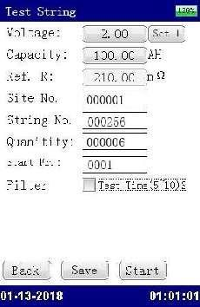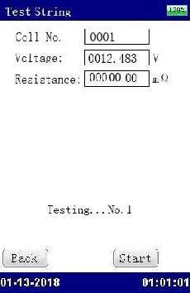

Fig 3.2.2.1 Fig 3.2.2.2 Fig 3.2.2.3
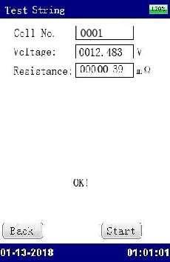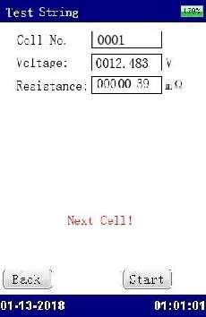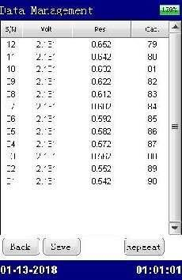

Fig 3.2.2.4 Fig. 3.2.2.5 Fig. 3.2.2.6

Site No.: User-defined, input the number for convenient data recording.
String No.: User-defined to distinguish it from other strings Quantity: Indicates the amount of cells in one string.
Start Fr.: Indicates the cell to begin the test in the string. In default setting, it will begin the test from the first (No. 1) cell.
Save: Save the existing cell type. Next time you enter this screen, you will see the same cell type.

After the above parameter setting (Fig 3.2.2.1), click “Start” to begin the measurement. Testing result of the first cell will displayed like Fig 3.2.2.4 when you hear the sound “Beep”. Then disconnect the testing clips, clamp on the next cell, measurement of next cell will automatically begin. Measure in the same way until the last cell when you see measurement result for the whole string (Fig. 3.2.2.6).

After the measurement, don’t forget to click the button “Save” to save the measurement data. To review detailed data, please could also refer to 3.3 Data Management.

3.2.3 Test of Oscilloscope
This function could have a simple test for battery voltage. Select “Waveform” in main menu and you will see the screen as below (see Fig 3.2.3):
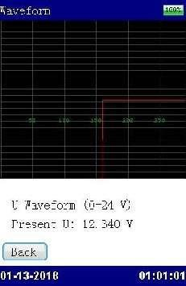

Fig. 3.2.3

3.3 Data Management
Testing data for battery string are saved in main unit memory as tests are finished. Maximally the Internal memory could save testing data for 100,000 cells. Before space is full, please transfer the data timely to PC by using the USB drive and USB converter.
For management, click “Data” in the main menu, and then go to the following screen:
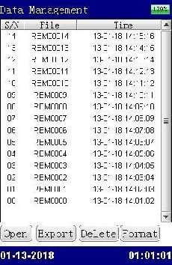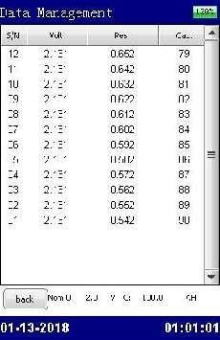

Fig. 3.3.1 Fig. 3.3.2 String test result
Select each line of measurement data, you could click to view the data or proceed to export to USB, delete it or format all measurement data.
Open: Click this button to view the testing result as Fig. 3.3.2.
Export: Select relevant item and click this button to save the testing result in the USB drive. Before this operation, make sure that the USB drive is well connected. You could import the measurement data from USB to PC software for more detailed data analysis and report generation.
Delete: Select the desired item and click this button to delete the record. Format: It is used to format all testing records.

NOTE: Please make sure that you have kept them properly before deleting or formatting the records.
Once deleted or formatted, the data could not be recovered.

To sort the measurement data from highest to lowest or lowest to highest, you could click on the item of voltage, resistance or capacity.

3.4 System Management
Click “System” in the main menu, and then you will see the following screen for system management (see Fig 3.4). For detailed instruction, please check the context below.
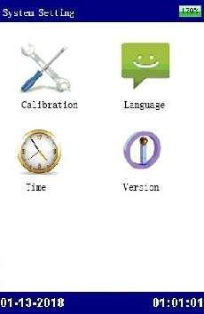

Fig. 3.4

3.4.1 Instrument Calibration
This section is for calibration of the unit. For the whole process of calibration, you will require some specific facilities and a more detailed instruction from us. Please contact your supplier if you need this.

3.4.2 Language
This is switch the displaying language of the Analyzer. Currently it supports Chinese and English. After the selection, please click save to keep the change.
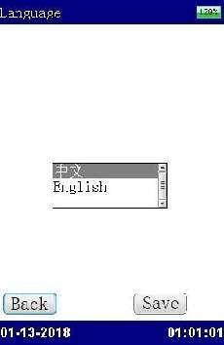

Fig 3.4.2

3.4.3 Time Setting
Click “Time” for date and time setting. The Screen will be seen as below (see Fig 3.4.3). After the setting, click “Save” to save the change.
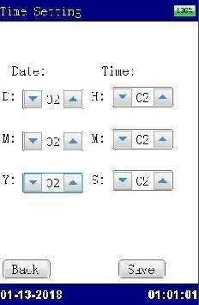

Fig 3.4.3

3.4.4 Firmware Version and Update
To view the existing firmware info, please click “Version” under system setting. You will see the basic info of the Analyzer including firmware version.
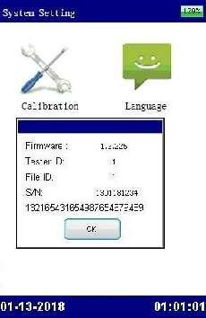

Fig 3.4.4A

ENS-7700IRenjoys free firmware update from us. The update is done by direct connection with USB drive. Please update in this method:

Save the two files (like “1.3.225.txt” and ” image.bin”) in the root directory of USB drive, connect the USB drive with Analyzer main unit, press the left button while restarting the unit. You will see the process screen for update in blue screen. Release the button and update will be done in short time.
Then the screen will automatically go to the starting screen.
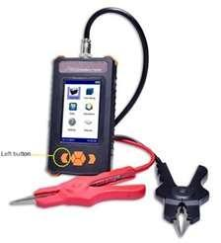
Fig 3.4.4B

4. DATAVIEW SOFTWARE
All testing data are saved in ENS-7700IRmain unit and it could be transferred to computer for data view. The following software should be well installed to enable the data analyzing. This software will help you know battery health status comprehensively. Application Software is included in the attached USB drive. This software will comply with Operation Systems of Windows XP and Win 7.

4.1 Software Installation/Uninstall

4.1.1 Software Installation
- Start your computer
- Stop all applications running in the computer (recommended).
- Connect the Our USB with computer.
- Find installation folder and double click the file named “ENS-7700IR Battery Condition Analyzer Data View setup.exe” to start the installation.

After installation is done, you will see the icon 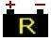 on the desktop. If you could not see it on desktop, it can also be found in “Start” menu.

4.1.2 Software uninstall
To install the software, please follow these steps: Start → program →7700IRBattery Condition
Analyzer Dada View → Uninstall7700IRBattery Condition Analyzer Data View

4.2 Software Operation
This analyzing software is applied to ENS-7700IRBattery Condition Analyzer. Any generated report will be saved automatically in the PC. You could save, delete or print testing data as per your need.
To start the software, double click the icon. And the main screen will pop up as Fig 4.2.a. You will see the example data in the screen. This example could be deleted after you have imported your data.
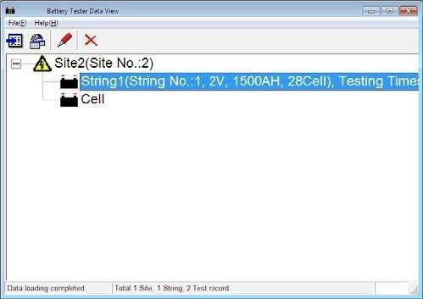
Fig 4.2.a

4.2.1 Import Data
All testing data are saved in ENS-7700IRmain unit and it could be transferred to computer via USB drive for data analyzing. For proper operation, please use only our product's USB drive.

Click “File” and then “import”, a box will pop up like Fig 4.2.1.2
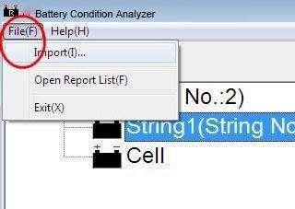

Fig 4.2.1.1
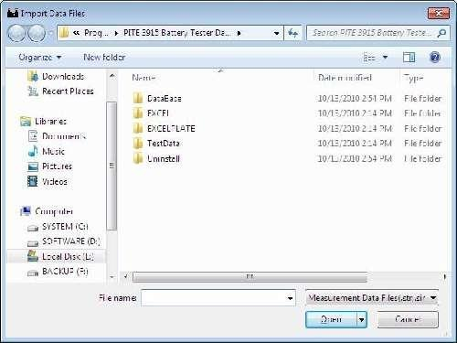
Fig 4.2.1.2
Open
Select relevant testing data that are already saved in the PC and click to import.
Open
NOTE: To import several files simultaneously, you could use keys like Ctrl or Shift for multi-selection and click to import.

4.2.2 View & Delete Data
The imported data is showed on the main screen like Fig 4.2.2.a. It includes the information for site, string test and cell test. Site number and string numbers are in accordance with the numbers predefined in ENS-7700IRmain unit. All testing data will be grouped in different sites with string and cell testing data below.
String includes string number, voltage, capacity, cell quantity and testing times.
Fig 4.2.2.a
Select site or string item and click right; you could carry out functions of Add, Modify and Delete. See Fig 4.2.2.b and Fig 4.2.2.c
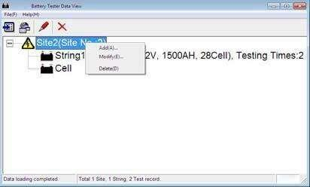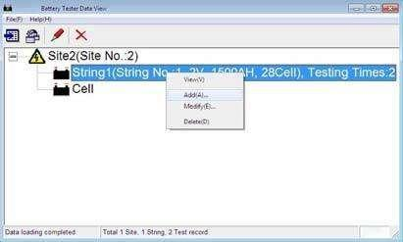

Fig 4.2.2.b Fig 4.2.2.c
Add: You can add new information for another site or string as figures (example) below. Testing result imported in the future will be grouped accordingly based on the setting for same site number and string number.
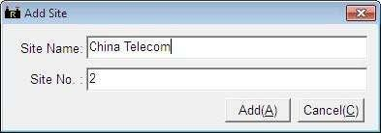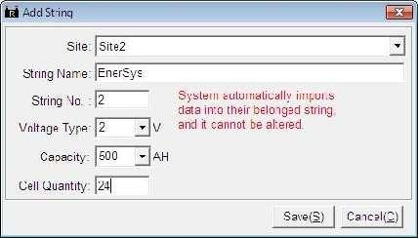

Fig 4.2.2.d Add Site Fig 4.2.2.e Add String
Modify: This function is used to rename sites and strings. This will help users remember each site and string easily. As this information is changed, relative information will be changed accordingly in the test report. We will introduce this later. See modify screen on the following Fig 4.2.2.f and Fig 4.2.2.g
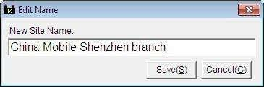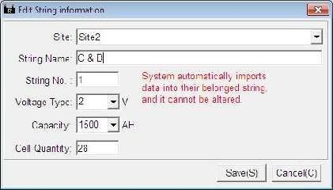

Fig 4.2.2 For Site Fig 4.2.2.g For String
Delete: You could delete the testing data if necessary. Before delete it, make sure you have kept the record properly.

4.2.2.1 View String Data
1) View Data
Double click string item and you will see the string data box on the screen. It displays the detailed testing data for strings in different time. The testing data includes test time, string voltage, resistance, capacity and status. Percentage of each battery status will also be displayed on the top with different colors.
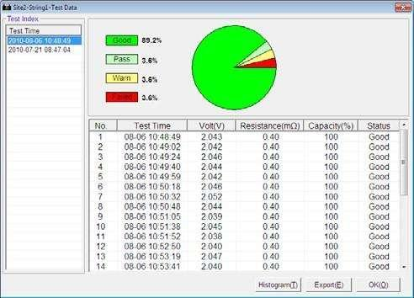
Fig 4.2.2.1.a
Double click relevant Test Time (if the same string is tested for several times) on the left to view testing data of each cell in the string.

NOTE: For convenient data view, you could sort out data in sequences like below:
Test Time
- Click on the left, the following items in the box will be sorted automatically. See Fig
4.2.2.1.b
No. | , | Test Time | , | Volt | , | Resistance
- You could sort out testing parameters of each string by clicking ,
Capacity | and | Status
. See Fig 4.2.2.1.c
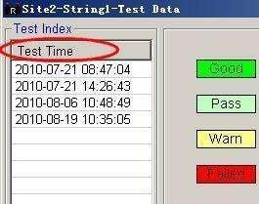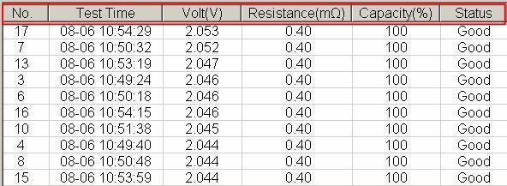

Fig 4.2.2.1.b Fig 4.2.2.1.c
- View Histogram
Histogram visually displays string performance in all aspects including voltage, resistance and capacity.
Histogram
Click button (in Fig 4.2.2.1.a) to view the histogram of the current string data. See Fig 4.2.2.1.d for example.
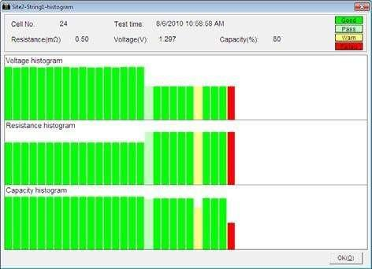
Fig 4.2.2.1.d
Move the cursor on each column of the histogram; you will see relative testing result (cell number, time, resistance, voltage and capacity) of each cell on the top.
OK
Click to close the window.

- Export Data
Export
Click the button (in Fig 4.2.2.1.a) and the selected data will be generated as a report in the format of Microsoft Excel like Fig 4.2.2.1.e. This report will be automatically saved in your computer. To find out where it is, click “File” and then “Open Report List” in the toolbar of main screen.
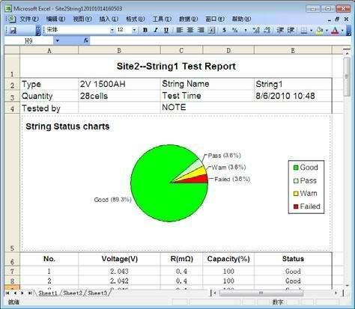
Fig 4.2.2.1.e
You could edit the report if necessary. If your PC is well connected with printer, you can print it directly.
NOTE: Please install Microsoft Excel2000 above version before you export the data.

- Delete Data
Select the test time, right click and select “Delete” to erase the record.
For multi-selection, you could use keys of Ctrl or Shift.

4.2.2.2 View Cell Data
1) View Data
Double click the item “Cell” under each site in main screen, cell test data will be exemplified as below:
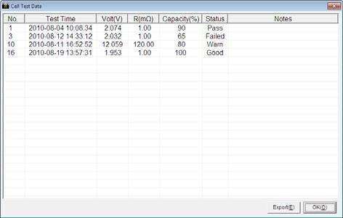
Fig 4.2.2.2.a
Notes
Parameters of the cells like testing time, voltage, resistance will be displayed. Like string data view, you could click each item to sort them out in sequences. To add some comments of each cell, you could directly double click the boxes below to input your comments, or you could select one cell data, click right and then “Add Comment”. See Fig 4.2.2.b for example.
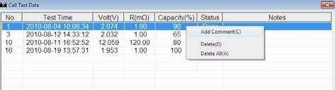

Fig 4.2.2.2.b
3) Export Cell Data
Export
Click the button to export cell test report into an Excel Form like Fig 4.2.2.c
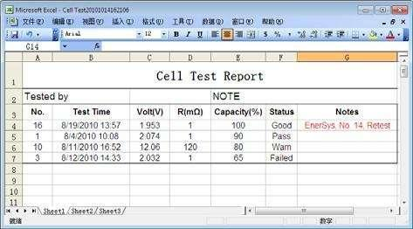
Fig 4.2.2.2.c

4.3 Help
Click Help → About, and it displays the detailed information of ENS-7700IRBattery Condition Analyzer Data View Software like Fig 4.3.a.
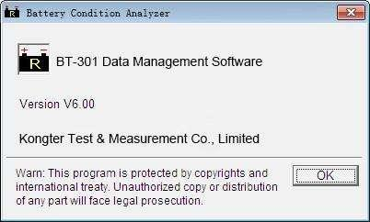
Fig 4.3.

4.4 Hot Key
On the top the DataView main screen, there are some shortcut keys with means as below:
Import Data
View Data. Select string or cell item and click the button to view the test data.
Modify site or string information. Select site or string item and click the button to edit test information.
Remove site or string data. Select site or string item and click the button to erase it.

5. SERVICE AND MAINTENANCE

5.1 Cleaning
Please clean ENS-7700IRmain unit and its accessories with soft damp cloth and a mild cleaner. Do not use abrasives, solvents, or alcohol, because they can deform or discolor the tester and accessories. After cleaning voltage testing clip with software cloth, clean it again with water and wipe it. Do not damage the metal part of the clips to ensure its accurate performance during testing.
WARNING: For your own safety, make sure that the main unit and accessories are not connected with the power supply before cleaning.

5.2 Storage
After using BT-301, put the main unit and all its accessories into the carrying case, and store the case in ventilating place under proper temperature and humidity. Never expose the Tester and its accessories to water, high humidity, or dampness. If not used for a long time, the Li-battery will discharge itself gradually. To keep its best performance, you are suggested to charge the battery periodically, like once a month.

5.3 Battery maintenance
When the7700IRis delivered from factory, it may not be power off. Please charge it before operation. In the status of charging, the charging indicator is red. When it is full-charged, the indicator turns green. It could be used for about 5 to 6 hours if the battery is full charged.
NOTE: Long time charging will not damage the battery, however, personnel is needed to look after it.

To gain maximum performance of the battery, you are recommended to activate it by full discharging and then full charging approximately 4 times a year.

6. FAQ
Q: Main unit has no response after power is on.
A: Maybe battery is power off. Please restart the main unit after connecting with charger. If main unit works, you could either keep the connection and carry out the operation or use it after battery is full charged.

Q: After main unit is power on, it buzzes.
A: Main unit has not enough power, charge it.

Q: Main unit menu is normal but has no reaction when it has external connection.
A: Main unit has not enough power or the wirings are not well connected. Please check the wiring well.

Q: Operation time is too short.
A: Battery problem, please reactivate it.

Q: Main unit is down with frozen screen during testing.
A: External interference is too strong. Generally it is caused when ground probe touches the live line.
Please restart the main unit and try again.

7. APPENDIX
Reference for battery capacity, resistance and voltage:
